

Trust Grade Doctor (ST3+ equivalent) in Geriatric Medicine
March 2026


Job description
Position | Trust Grade Registrar Doctor (ST3+ equivalent) in Geriatric Medicine
Grade & Salary | ST3+ equivalent (plus allowances for on calls)
Location | The Princess Alexandra Hospital
Hours | 40 hours per week
Responsible to | Consultant Geriatrician
Accountable to | Divisional Medical Director
Our Organisation
The Princess Alexandra Hospital NHS Trust (PAHT) provides a full range of general acute, outpatient and diagnostic services at The Princess Alexandra Hospital in Harlow, the Herts and Essex Hospital in Bishop’s Stortford, and St Margaret’s Hospital in Epping.
We employ 3,500 staff and serve a local population of around 350,000 people living in west Essex and east Hertfordshire, centred on the M11 corridor and the towns of Harlow, Bishop’s Stortford and Epping. Our extended catchment area incorporates a population of up to 500,000 and includes the areas of Hoddesdon, Cheshunt and Broxbourne in Hertfordshire.
Our Values
The Princess Alexandra Promise to our patients as identified by our 3 values which will contribute to improving our patient experiences:
Patient at heart – Always holding the patient and their wellbeing at the centre of our thoughts and efforts
Everyday excellence – Sharing and celebrating our successes, being honest when we get it wrong, giving us the ability to learn from both
Creative collaboration – Knowing strength comes from diversity, we combine our experiences, skills and talents, working together to find new and better ways to care
The Trust believes in investing in all our staff and rewarding high standards of care whilst building for excellence and in return we expect our staff to uphold the Trust values to the highest level.

Department Structure

Consultants
Dr Jane Snook | Care of the Elderly/Orthogeriatrics
Dr Ainkaran Muthiah | Care of the Elderly/Parkinson’s
Dr Sree Sakthi | Care of the Elderly/Frailty Lead
Dr Kapilla Gunasekera | Care of the Elderly
Dr Urvashi Jain | Care of the Elderly
Medical Division management team
Divisional Medical Director | Dr Sree Sakthi
Clinical Service Group Lead | Chee Eng Lee
Divisional Director of Nursing | Victoria Andrews
Divisional Director | Gail De Souza
General Manager Medical Specialties, Frailty & General Medicine | Emma Bright
Service Delivery Manager | Natalie Howlings
Assistant Delivery Manager | Kayleigh Thompson
Job summary
The successful applicant will jointly be responsible for supervising Care of the Elderly ward in-patients and reside t doctors, outpatient clinics and ward referrals from other firms (with consultant supervision). The successful applicant will take part in the acute medical take on call rota. Full induction from both a corporate and local perspective will be provided.
The admissions are an unselected acute adult medical take. The post will work under the supervision of the Care of the Elderly Consultants for both inpatient and outpatient work.
The post holder will conduct ward rounds with the resident doctors, ensuring all patients are seen daily. This will develop leadership and supervision skills as the Registrar is a key link in co-ordinating resident doctor leave on the ward and ensuring that all patients are safely reviewed when shortfalls occur.
The Registrars play a key role in ensuring medical team input into the Red2Green at the board round meetings which takes place twice daily on each ward. This is a ward based, mini-MDT in which the treatment and discharge plan for each patient on the ward is reviewed with a view to eliminating bottlenecks and non-treatment related delays.
The post holder will assist in teaching and supervising the FY1 and FY2 and IMT 1/2 in practical procedures and in their clinical learning.
The post operates at the ST3 level or above (dependent on the post holder’s experience and qualifications) within the firm structure and as such is most suitable for a candidate with MRCP wishing to gain further experience at ST level in Care of the Elderly Medicine and General (Internal) Medicine. The post offers excellent experience in acute General and Care of the Elderly Medicine.
The post holder will work closely with the medical team and wider multidisciplinary clinical team in his/her area of work to deliver high quality patient care. The post holder will also support the consultant in driving forward service improvements according to the changing and increasing needs of the population.
The post holder will report directly to the consultant in their area.

Main duties and responsibilities
- To co-ordinate high quality person-centred care of the patients on the ward, ensuring that all patients admitted have a diagnosis and treatment plan, and receive a daily medical review.
- To participate in outpatient clinics where required.
- To provide senior medical leadership on the ward by supporting and supervising more junior staff and delegating duties appropriately.
- To ensure the appropriate discharge of patients, including providing timely paperwork to the General Practitioner ensuring a continuation of care following discharge.
- To actively participate in any appropriate steering or project groups.
- To build and maintain excellent relationships with all members of the multidisciplinary team, working with them and communicating effectively to deliver high quality patient care.
- To engage fully in development of services, driving forward innovations to meet the anticipated future challenges of the ageing population.
- The post holder will be a member of the Medicine Divisional Group and will be expected to participate in the activities of the directorate as indicated.
- To assist the Trust in reaching external targets without compromising good quality patient care.
- To understand and be committed to adult and child safeguarding requirements.
- To fulfil the statutory and mandatory training programme as per the Trust policy
- To uphold confidentiality of all patient records and Trust information. Maintain a clean, safe environment and adhere to Trust’s infection control standards
- To arrive on time for duty and be available for work from the arranged start time
- Comply with Trust policies, including upholding the trust’s values and behaviours
This job description may be subject to change according to the varying needs of the service. Such changes will be made after discussion between the post holder and the manager. All duties must be carried out under supervision or within Trust policy and procedure.

Working patterns
The post holder will be based on one of the Geriatric Medicine wards overseeing the care of the inpatient on that ward alongside the consultant. There will be times where redeployment to other General Medicine wards will be in place to support with safe staffing. The post holder will also be required to be a part of the on call rota which includes long days, twilights, weekends and night shifts. The on call rota cross covers medicine wards and acute areas.

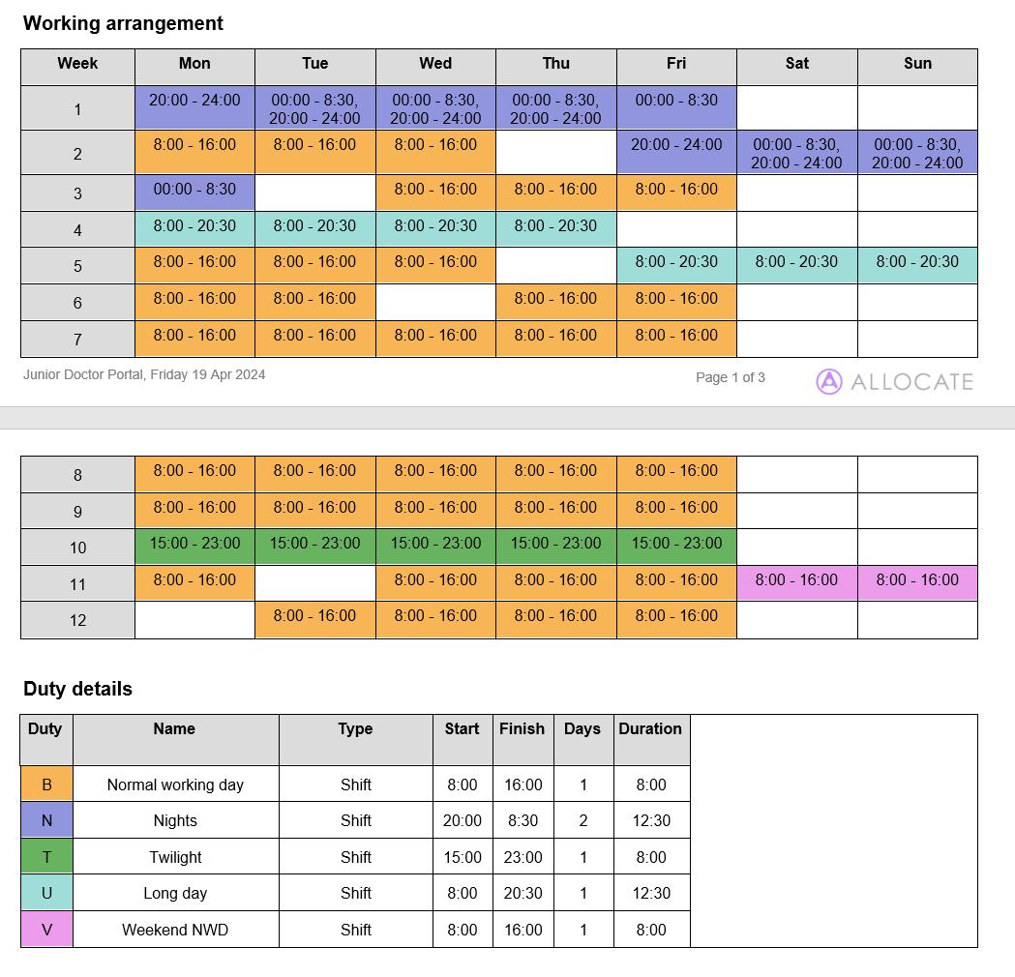

Education and Research
- To participate in weekly departmental teaching sessions. The ST will be allocated an Educational Supervisor who will be one of the qualified educational supervisors. The post holder has a statutory obligation to attend all mandatory training.

- Monthly half-day audit meetings are held within protracted time as designated by the regional timetable. Attendance at all meetings listed is compulsory.

- A key responsibility of the post will be the self-development through education.

- Clinical research is encouraged within the Trust and facilities in place to enable the post holder to undertake research projects in his/her area of interest.

- The Trust has an active R&D department led by a Clinical Director and team of specialist nurses.
- You will have a named Educational Supervisor and protected time with them each week.

- The trust has a study leave policy. This provides financial support for study leave. There is also access to regional training.

Clinical Governance and Audit
- The NHS Executive has defined Clinical Governance as:
- ‘’A framework through which NHS organisations are accountable for continuously improving the quality of their services and safeguarding high standards of care by creating an environment in which excellence in clinical care will flourish.’’
- In line with Government requirements, the Trust has established a Clinical Governance Committee. The Chief Executive is the accountable officer and the Chief Medical Officer who is responsible for ensuring that systems for clinical governance are in place and monitoring their continued effectiveness.
- As part of the requirements of clinical governance, the Trust’s Committee is ensuring that all hospital doctors participate in audit programs, including, where appropriate specialty and sub-speciality national audit programs endorsed by the Commission for Health Improvement.
- The post-holder will participate in monthly medical audit and clinical governance meetings at PAH.
- The post-holder will be responsible for ensuring that they take any appropriate action required with regards to governance and risk management in line with relevant regulations, policies and procedures.
Person specification
Position | Trust Grade Doctor (ST3+ equivalent) in Geriatric Medicine
Grade | Specialty Registrar (ST3+ equivalent)

Evidence for suitability in the role will be measured via a mixture of application form, testing and interview. Essential: E Desirable: D

Trust values
Patient at heart – Always holding the patient and their wellbeing at the centre of our thoughts and efforts | E
Everyday excellence – Sharing and celebrating our successes, being honest when we get it wrong, giving us the ability to learn from both | E
Creative collaboration – Knowing strength comes from diversity, we combine our experiences, skills and talents, working together to find new and better ways to care | E

Education and qualifications
GMC registration with a licence to practice | E
PACES | E
Valid ALS or equivalent | D

Experience
Knowledge and experience of geriatric medicine and UK acute medicine and ambulatory care | E
Evidence of personal practice in all areas described by the RCP curriculum | E
Experience of guideline appraisals | E
Participation of relevant audits | E
Experience of literature appraisal and report writing | E
Evidence of implementing relevant evidence-based medicine | D
Implementation of evidence based guidelines | D
Participation in relevant national audits | D

Skills and knowledge
Understanding of principles of clinical governance | E
Ability to interpret and apply clinical research | E
Understanding of patient safety and risk management | E
Knowledge and understanding of ‘good medical practice’ from the GMC and its requirements | E

Personal qualities
Organise and prioritise workload | E
Accountability of patient care | E
Work effectively as part of a multi-disciplinary team | E
Time management | E
IT literate | E
Excellent verbal and written skills in English | E

