
The Princess Alexandra Hospital

NHS Trust

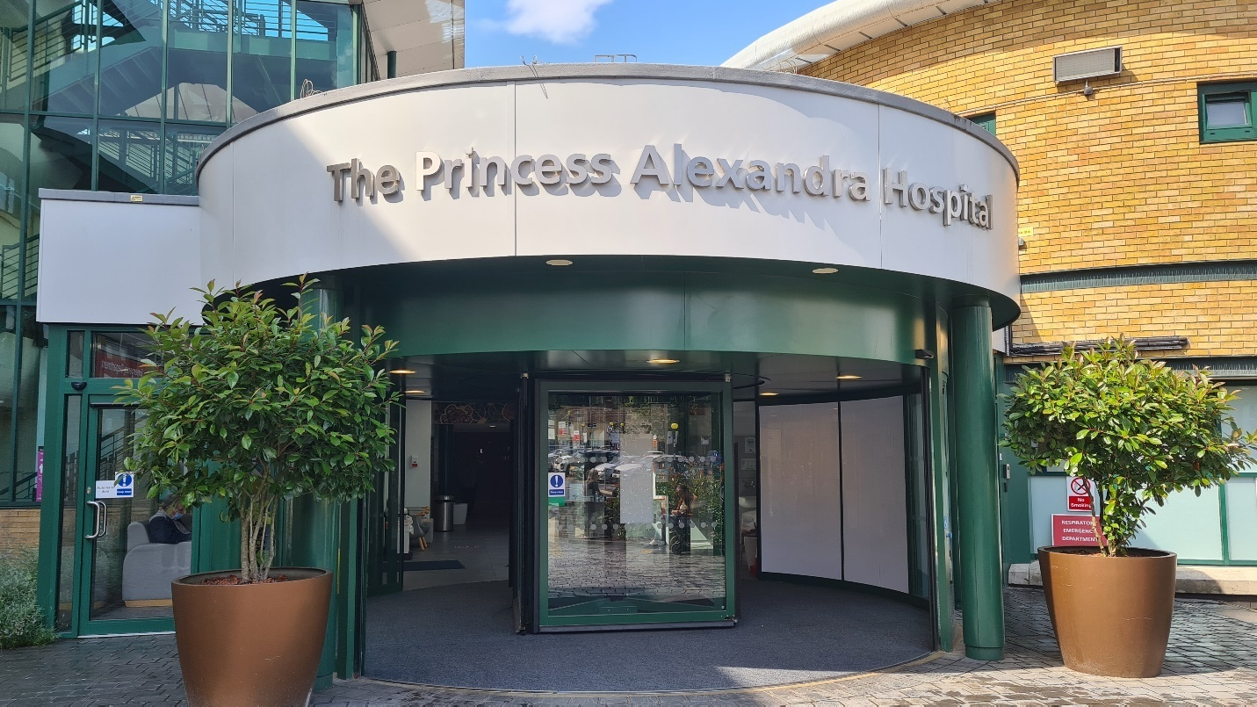

Job Description: Consultant Emergency Medicine

Job Title: | Consultant in Emergency Medicine
Specialty: | Emergency Medicine
Accountable to: | Medical Director
Reporting to: | Clinical Director

Job Purpose
The successful candidates will join our existing team of 13 Consultants along with a number of SAS Doctors, Resident Doctors, Advanced nurse practitioners, ENPs and Physicians’ associates. These new posts, following a recent successful business case, are to increase the Consultant cover within the Emergency Department and be able to drive and deliver excellence in line with the Trust’s vision for future. Each successful candidate is expected to work 10 programmed activities per week.
General Information
The Princess Alexandra Hospital NHS Trust is a District General Hospital providing acute services to the
population of West Essex and East Hertfordshire from a 489 bedded site in Harlow, Essex (PAH). The trust also encompasses two Community hospitals, St Margaret Hospital (SMH) in Epping and the Herts & Essex Hospital (HEH) in Bishops Stortford. Originally opened in 1965, the Trust’s vision is to become one of the best District General Hospitals in the country basing its foundation on its three core values: Patient at heart Everyday excellence Creative collaboration

The Princess Alexandra Hospital NHS Trust (PAH) is now among the best performing Trusts in the country for many aspects of care, for example, cancer waiting times (number 1 Trust in December 2017), maternity services (rated as ‘outstanding’ by the CQC and some of the lowest rates for still birth), ‘End of Life’ and dementia services (specialist facility and practitioners for people with dementia at the end of their lives, enabling patient choice), infection control (some of the lowest MRSA, MSSA and C.Diff rates in the country), falls and pressure ulcers in hospital (below national average), delayed transfer of care from hospital rates (now a top 10 Trust), access to diagnostics (achieved standards every month for the last two years), and patients being treated within 18 weeks of referral from their GP (delivered consistently since August 2016, except in January 2018 owing to the national directive to stop operating during winter pressures). In addition to this the Trust has been nationally recognised for having one of the highest ratings from "Friends and Family" surveys. Focused on patient experience the Trust has launched a Patient Experience Department and Patient Panel which meets on a monthly basis, receiving presentations from clinical teams across the Trust describing the changes that are enabling the Trust to become more focussed on the needs of patients, families and carers. The latest CQC report reflects the many positive changes made throughout the Trust since its previous inspection report published in October 2016. As a result, we are now rated as ‘Good’ for Effective, ‘Good’ for ‘Caring’, and ‘Good’ for Well-led. Our Trust’s overall rating has risen from ‘Inadequate’ to ‘Requires Improvement’, which reflects the programme of quality improvement underway. Employing around 3,000 employees with vast amount of experience, skill and expertise, employee performance has placed the Trust amongst the best hospitals in England and Wales.

Locality
PAH is conveniently located in Harlow, Essex, with 25 minutes’ drive to London Stansted Airport and
30 minutes train ride to London Liverpool Street. Harlow also has excellent road connections across England which includes M11, M25, A10, M1 and A1 all in close proximity and PAH site is within walking distance to the Town Centre. One of the original New Towns, designed by architect Sir Frederick Gibberd to ease overcrowding in London following World War II, Harlow is a vibrant community with many attractions to appeal to visitors and residents alike including, Parks, Gardens, Art Galleries, Shopping Malls, Theatres, good Schools and Sports/Leisure facilities. Harlow is both one of the most modern and oldest settlements in England. Housing in the area is extremely varied, from ‘picture postcard’ cottages to well-planned estates of modern houses and flats.

Scope and Range
The successful candidates will work at Princess Alexandra Hospital, within the Emergency Department (ED) which has approximately 120,000 attendances per annum of which 25% are children. The Emergency Department is located at the front of the hospital and has recently undergone a number of changes. The structure and facilities of the department include the following:

- A four bay Resuscitation room with dedicated radiology facilities, new ultrasound machine and an arterial blood analyser, with an adjacent relatives’ room
- A five bay Rapid assessment and Treatment (RAT) area
- Another area for EM SDEC (Previously called ‘Minors’)
- 25 Cubicles – Majors area
- Dedicated Children’s ED with adjacent Paediatrics SDEC
- A dedicated ENT/Eye room with slit lamp
- Obstetrics and Gynaecology assessment room
- Separate cubicle with all requirements for Mental health assessment
- Urgent Treatment Centre: We have a dedicated well organised Minor injuries unit run by the Emergency Nurse Practitioners while the Minor illness patients are streamed to a purpose built GP service which lies in close proximity to the minor injuries. The UTC provides these services between 0830 and 2130 every day.
- A full diagnostic imaging suite, including X-Ray, CT, MRI and ultrasonography is nearby. CT is available 24 hours a day, 365 days a year
- A seminar room with teaching aids and computer
- On site Helicopter landing pad
- Immediately adjacent to the Emergency department are
  - Ambulance Cohort Area

Frailty assessment unit / Older people assessment and liaison unit (OPAL)
  - Same Day Emergency Care Unit (Medical and Surgical SDEC)
- The department is computerized with Alex Health EHR system (Cerner)
- Emergency Medicine has close working links with the other Clinical services:
  - Surgery and Critical Care
  - Women and Family Services
  - Cancer, Cardiology & Clinical Support
- We are a trauma unit, part of the East of England trauma Network. Major trauma patients are transferred to Addenbrooke’s Hospital, Cambridge as the major trauma centre
- Our patients with myocardial infarction go to Basildon Hospital for PPCI.
- Our stroke patients go to Queen’s Romford/Lister Stevenage
- We have all the major specialties on site, including critical care, general and geriatric medicine, cancer medicine, general surgery, vascular surgery, orthopaedics, gynaecology, paediatrics and mental health. There is a large maternity unit rated as Outstanding by the CQC and NICU facility and a large ophthalmology department, with adjacent ENT and maxillofacial services.
- The Department has dedicated Streaming desk and 24 hours ED Reception team
- There is a Staff room with all facilities for rest/break

Key Personnel and Staffing
Dr Bethan Graf | Divisional Director for UEC
Dr Gnana Singaravadivel | Clinical Director for ED
Dr Andrea Annoni | AMD for Mortality and Risk
Dr Kashif Malik | College Tutor and Consultant Emergency Medicine
Dr Mary John | Consultant Emergency Medicine
Dr Teifion Davies | Consultant Emergency Medicine
Mr Mir Aman Khan | Consultant Emergency Medicine
Dr Roberta Branisteanu | Consultant Emergency Medicine
Dr Ahmad Hossam | Consultant Emergency Medicine
Dr Bilal Ahmad | Consultant Emergency Medicine
Dr Rishi Gupta | Consultant Emergency Medicine
Mr Suneil Ramnani | Consultant Emergency Medicine
Dr Mathu Santhakumar | Consultant in Paediatric Emergency Medicine
Dr Noel Fernando | Consultant in Critical Care and Emergency Medicine
Following recent increase in the staffing establishment, senior and resident staffing in the department includes the following.
28 – Specialty Doctors and Higher Specialty Trainees ST4-ST6
30 – Resident Doctors (ACCS CT1, ST3 EM, GPST, FY2, FY3 Clinical fellows and Trust Grade ST1-2) 7 – Advanced Nurse Practitioners (5 seniors and 2 trainees), 1 – Physician Associate
In addition, there are adequate number of ENPs and GPs to run the UTC.
There is shop-floor senior cover (Registrar level) 24/7 and Consultant presence from 8am to 10pm.

Principle Duties and Responsibilities of the Post
Emergency Medicine sits within the Urgent and Emergency Care (UEC) division which is led by a
Divisional Medical Director (AMD) who is supported by the Divisional Director of Operations and the Divisional Director of Nursing. The successful candidates are accountable to the Medical Director. The following are considered to be the main duties and responsibilities of the post holder.
- To provide Departmental Leadership acting as the senior in charge, including direction and supervision of other doctors and nurses and the provision of clinical advice and microteaching.
- To advise and decide on investigations appropriate to a given situation and in assessing the significance of results.
- To work with the shift-coordinator and site team to ensure the safe and smooth running of the Department.
- To see, treat and discharge or refer ED patients as appropriate.
- To run all Trauma and Cardiac Arrest Calls, or directly supervise a resident clinician running the call for Educational purposes.
- To liaise with the Site Manager, CSG Lead, Head of Nursing, General Manager, on-call Executive/Manager and/or Consultants from other departments as necessary to raise awareness of risks to the department, and to work together to mitigate clinical risk, especially during periods of high patient volume or acuity.
- To be responsible for the running of the Emergency Medicine SDEC.
- To actively participate in the Clinical governance and patient safety & quality (PS&Q) activities.
- To take part in or lead appropriate research/quality improvement projects.
- To support the teaching, training and development of resident doctors, nursing and allied health professional staff.

The above list is an outline only, not exhaustive, and may be altered from time to time to suit the needs of the Service. The post holder will be required to be co-operative and flexible in accordance with the needs of the Department and the Trust. We currently provide Consultant cover from 8am until 10pm 7 days a week and aim to build further on this cover as number of Consultants increases.

Work Pattern and Job Plan
Work commitments will be based on a 10 PA job plan within which 2.5 PA is allocated for SPA per week. The pattern of work is variable but includes the following.
- 7.5 PA DCCA
- 2.5 PA SPA
- 1 APA for out of hours supplement, but will change subject to recruitment
- On-call commitments: 1 in 12 currently, but will change subject to recruitment.
- Weekends: 1 in 12 on calls currently, but will change subject to recruitment.
Job plan will be agreed within the first 3 months of appointment as per Trust Job planning process based on the department’s and the individual’s requirements. The work pattern is subject to changes based on the Trust requirements and the ongoing recruitment.

Communications & Relationships
- To participate fully in the management of the Department and to liaise closely with the
Operational Manager, Specialty Lead Doctors, AMD and ED Consultant Colleagues
- Able to liaise effectively with colleagues both locally and in other centres

Post Graduate Education
The Postgraduate Medical Centre at Harlow is housed in the 19th Century Parndon Hall, which is in the grounds of Princess Alexandra Hospital. This Post Graduate Centre has a library, a lecture theatre
a quiet study room and an IT resource room. There is one trust librarian and six library assistants. Current journals and back issues of journals covering all the main health care specialities are stocked and computer access is available to Best Evidence, British Nursing Index, CINAHL, Cochrane Library, ENB, HMIC, Medline and National Research Register. A member of the library staff can search other databases on your behalf. Access to NHS net is also available. There are comprehensive postgraduate teaching programmes, journal club and GP meetings. The Trust has a number of teaching hospital links, particularly with the Royal London Hospital Trust, University College and London School of Medicine and takes part in medical student teaching and postgraduate rotations.

The Trust supports the requirements for continuing professional development (CPD) as laid down by the GMC and Royal colleges and is committed to providing time and financial support for these activities.

Library Facilities:
Hours of opening – 0900 to 1730 (Mon to Thurs), 0900 to 1700 (Fri). Out of hours there is access to the quiet study room

Educational activities, Audits and Quality improvement
The department offers dedicated weekly teaching every Wednesday and Thursday afternoons (Wednesdays for residents (FY2/ST1-2 level) and Thursdays for Seniors (Registrar level). The teaching programme is based on the RCEM curriculum, chaired by the Consultants. The Post Graduate and Resuscitation teams at PAH run various teaching and training programmes across the year which the successful candidate is welcome to actively participate and contribute. There are dedicated Simulation sessions for ED staff conducted by Resuscitation team and ED Consultants. ALS, EPALS and Trauma team essential course are periodically organised within the Trust.

Audits and QIP: The post holder is expected to actively participate in the Departmental, NICE and RCEM National audits. The interested clinician will be encouraged and supported to contribute towards Quality improvement projects as we care committed to improving the emergency care for our patients. New improvement ideas are always welcome. Monthly half day audit sessions are held within the Trust, which regularly include presentations from the multi-disciplinary team across for five NHS Trusts.

Annual Leave and Study Leave
Annual and Study leaves will be offered based on National Terms and Conditions and is subject to local
Trust policy.

Person Specification

Criteria | Essential | Desirable
Qualifications | FRCEM or equivalent
Training | Training and experience equivalent to that required for UK CCT (or within 6 months of CCT/CESR being issued)
Eligibility | Full GMC registration and hold a current licence to practise  Entry on GMC Specialist Register in Emergency Medicine or eligibility for specialist registration in Emergency Medicine within 6 months from the time of the interview
Knowledge and Skills | Broad knowledge and experience of Emergency Medicine in UK  Evidence of personal practice in all areas described by the RCEM curriculum | Knowledge of Major Incident Procedures  Previous Consultant level experience in UK Emergency Medicine
Clinical Effectiveness | Understanding of principles of clinical governance  Ability to demonstrate personal continuing personal development  Experience of guideline appraisal Participation in relevant audits / QIP  Ability to interpret and apply clinical research | Implementation of evidence based guidelines  Recent published clinical research in peer reviewed journal
Courses | Valid ATLS, ALS, APLS (EPLS or  equivalent)  Emergency USS Level 1 | Instructor status in ALS/ATLS/APLS/EPLS  USS Level 2
Academic skills | Experience of literature appraisal and report writing

Safety | Understanding of and contribution to patient safety and risk management
Teaching | Experience in teaching at multiple levels and across disciplines | Attended Teaching the Teachers or similar course
Management and Leadership skills | Able to organise and prioritise workload  An understanding of accountability for patient care  Ability to work effectively as part of a multidisciplinary team  Evidence of management experience or training  Time management skills | Experience of team leadership or Leadership courses  Experience in departmental management duties e.g. Rota lead
Standards | Has a thorough knowledge and understanding of “Good Medical  Practice” from the GMC and meets its requirements
Personal attributes | Committed, Honest and reliable Resilient and able to adopt to demands Responsible, caring and patient centred Excellent verbal and written skills in English | Extracurricular activities  Achievements related to Emergency Medicine or outside

Trust Values
Our values support us all in the way we work together and care for our patients and each other. We each have a responsibility to live our values and put them at the centre of how we work with each other and care for our patients.

Patient at heart: Always holding the patient and their wellbeing at the centre of our thoughts and efforts

Everyday excellence: Sharing and celebrating our successes, being honest when we get it wrong, giving us the ability to learn from both

Creative collaboration: Knowing strength comes from diversity, we combine our experiences, skills and talents, working together to find new and better ways to care

Duty of Candour
The Princess Alexandra Hospital NHS Trust fully endorses the principles of being open and embraces the Duty of Candour. The Trust is committed to an open and fair culture and the overall approach expected within the organisation is one of help and support rather than blame and recrimination. All staff are expected to follow this approach.

Contact
For further information about the post and for an informal visit to the department, please contact
Dr Gnana Singaravadivel – Clinical Director for Urgent & Emergency Care (ED and UTC)
Email: gnanavadivel.singaravadivel@nhs.net Phone: 01279 444455 ED Secretary Extn: 3219

Job Description Agreement

Job Holder’s Signature:  Head of Department’s Signature: | Date:  Date:

